**Confidence Interval**

A **confidence interval** (CI) is a range of values, derived from a sample, that is used to estimate the true population parameter (like a population mean or proportion). It provides an interval within which the true parameter is likely to lie, with a certain level of confidence.

**Confidence Level**: This is the probability that the confidence interval contains the true population parameter.

Common confidence levels are 90%, 95%, and 99%.

For example, a 95% confidence interval means that if you were to take 100 different samples and construct a confidence interval from each, about 95 of those intervals would contain the true population parameter.

**Formula for Confidence Interval**

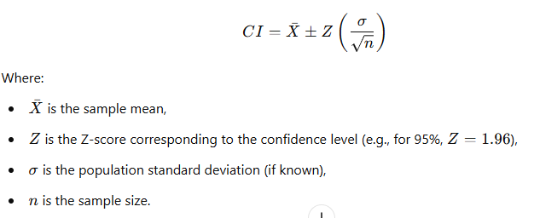

**Example:**

Let’s say you want to estimate the average height of a population of adult women. You take a sample of 100 women, and the sample mean height is 160 cm with a population standard deviation of 10 cm.

You want to calculate a 95% confidence interval for the average height of all adult women.

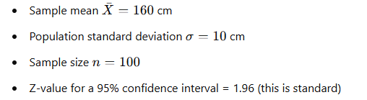

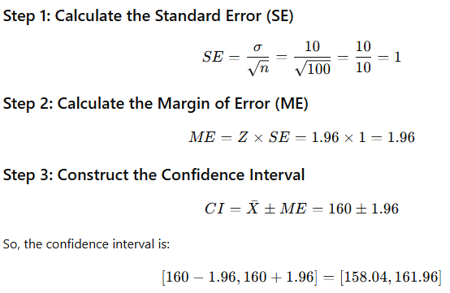

**Interpretation:**

The 95% confidence interval for the average height of all adult women is between **158.04 cm** and **161.96 cm**. This means we are 95% confident that the true average height of the entire population of adult women lies within this range.

The sample is a part of normal distribution.

Hence the probability that the sample mean will be in between -1 and +1, Z-score. 68.3 %

Or

With 68.3% confidence the sample mean will be in this range of -1 and +1, Z score/Std Dev

Likewise

The probability that the sample mean will be in between -2 and +2, Z-score. 95.5 %

The probability that the sample mean will be in between -3 and +3 Z-score. 99.7 %